IT WAS YESTERDAY

- Shiv Dutt, Indraprastha Engineering College

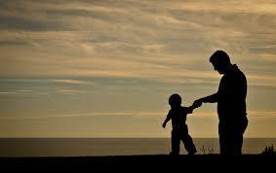

When I was just a small kid

Do you remember when,

the time you kissed my bruises

or cleaned my soiled chins.

It seems like only yesterday,

you wiped away my tears

And late at night I called your name

To chase my fears away

Though time has changed your handsome grip,

Your hair is snowy white,

Your gait a little slower now,

Thick glasses help your sight.

Oh! Do I thrust for years gone by,

To be that growing lad,

Reliving all of the memories of growing with my dad.

